

A resume is a customized marketing tool that specifically demonstrates your fit, skills, and competencies for the industry/job function you are targeting.

* The goal of a resume is to receive an invitation to an interview
* Use the job description to identify keywords and match your relevant skills

**General Formatting**

* Check grammar, spelling, and punctuation
* Use easy to read fonts (11-12 pt.) and no less than .5” margins
* No more than two pages (for most industries)
* Do not use first-person language (no “I,” “me,” nor “we”)
* Avoid templates, columns, text boxes- might not be read by an Applicant Tracking System (ATS)
* Determine format- reverse chronological, skills-based, hybrid. See resume examples (next page)

**Elements of a Resume**

**Contact Information**

* Name, city, state, phone number, email, and LinkedIn URL (if you have one)

**Title Job You Are Applying For**

* Replaces “Objective”

**Summary of Skills**

* 1st section of your resume that makes it easy for the reader to quickly see you have the skills needed to do the job
* Identify keywords listed in the job description and match to your relevant skills

**Relevant Experience and/or Work History**

* Demonstrate the value you brought to employer, i.e., saved money, time, resources
* Use strong action verbs to describe work (coordinated, maintained, collaborated)
* Quantify and qualify by adding #’s, %, $, etc.
* Only list positions that are within the last 15 years
* Include non-paid positions if relevant

**Education and Training**

* Include only relevant education/training
* Do not include dates if completed more than five years ago

**Volunteering/Community Involvement**

* Include in Relevant Experience/Work History section if directly related to the job you are applying for

**Additional resources:**

*Resume and Job Seeker workshops:* [*https://www.larimer.org/ewd/workshops/job-seeker-workshops*](https://www.larimer.org/ewd/workshops/job-seeker-workshops)

*or email us at:* *lcewd-workforceconnections@co.larimer.co.us*

CREATING YOUR RESUME

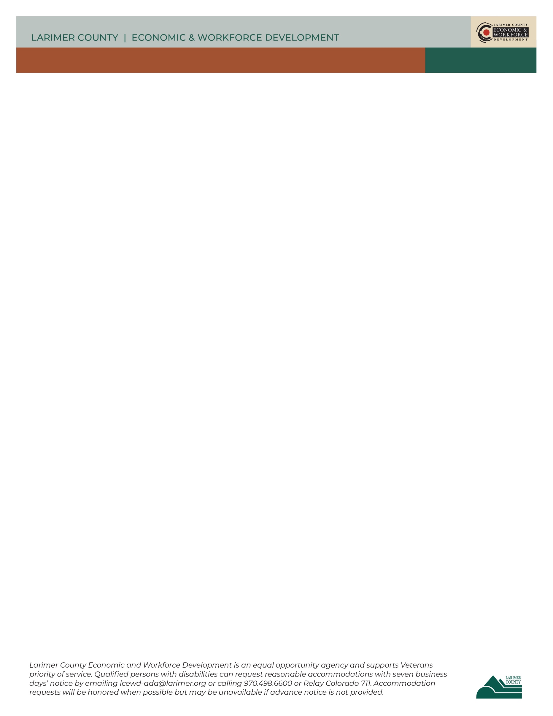

**CHRONOLOGICAL RESUME**

**JENNIFER JONES**

Fort Collins, CO 80525 | 970.123.1234 | [jjones@gmail.com](mailto:jjones@gmail.com) | www.linkedin.com/in/jennifer.a.jones

**OFFICE MANAGER**

* Provided more than 10 years of efficient, friendly customer service
* Organized with attention to detail
* Proficient in Microsoft Office Suite
* Superior listening skills and problem-solving ability
* 7 years’ experience overseeing staff of 12 people

**RELEVANT EXPERIENCE**

**Administrative Assistant** | ABC Company | Fort Collins, CO May 2013 – March 2020

* Assisted up to 100 customers per day, answered procedural questions, directed customers to staff and resources, and helped customers with complex paperwork unfamiliar to them
* Maintained accurate files and records for 25 separate government assistance programs
* Programs audited annually with 0% error
* Transcribed accurate meeting notes for team, staff, and executive meetings
* Trained and mentored all new administrative staff

**Receptionist** | 123 Association | Fort Collins, CO June 2009 – April 2013

* Answered and redirected over 150 calls daily using a 10-line phone
* Greeted more than 60 walk-in customers daily
* Scheduled appointments and meetings for 15 managerial and 4 executive staff

**Office Support Intern** | Top Company | Fort Collins, CO June 2006 – April 2009

* Filed forms and invoices using alphanumeric systems
* Sorted and delivered incoming mail to line staff and managers
* Made copies and sent faxes using state-of-the-art office machines
* Transcribed accurate notes of staff meetings

**EDUCATION AND TRAINING**

**Associate of Arts, Business & Technology**, Emily Griffith Opportunity School, Denver, CO

**Microsoft Office Certification**, Front Range Community College, Fort Collins, CO

CREATING YOUR RESUME



CREATING YOUR RESUME

**SKILLS BASED RESUME**

**JENNIFER JONES**

Fort Collins, CO 80525 | 970.123.1234 | [jjones@gmail.com](mailto:jjones@gmail.com) | www.linkedin.com/in/jennifer.a.jones

**OFFICE MANAGER**

* Provided more than 10 years of efficient, friendly customer service
* Organized with attention to detail
* Proficient in Microsoft Office Suite
* Superior listening skills and problem-solving ability
* 7 years’ experience overseeing staff of 12 people

**RELEVANT EXPERIENCE**

**Customer Service**

* In contact with up to 100 customers per day via telephone, email, and in-person
* Solved procedural and paperwork problems related to 25 separate government grants and assistance programs for customers
* Provided knowledgeable, efficient, accurate, and personable service to customers resulting in 98% first-submission acceptance of complex program applications

**Organization/Data Management**

* Kept appointment and meeting schedules for 20 managerial and executive staff
* Organized eight professional 3-day conferences: locations, meals, speakers, technical equipment, registration, and follow-up
* Maintained data on 25 government grants and assistance programs: eligibility, deadlines, program changes, grant review processes, funding levels. Tracked application processes, notifying applicants of upcoming changes and deadlines
* Kept demographic and process data for participants, grant applicants, and successful grantees as per requirements of individual programs

**Leadership/Communication**

* Trained all new office hires: duties, policies, procedures, customer service, problem-solving, office and company culture
* Routinely used appropriate chain of command to convey executive/managerial decisions and changes in procedure to line staff and to convey questions, concerns, and ideas from staff to managerial and executive levels

**WORK HISTORY**

**Administrative Assistant** | ABC Company | Fort Collins, CO May 2013 – March 2020

**Receptionist** | 123 Association | Fort Collins, CO June 2009 – April 2013

**Office Support Intern** | Top Company | Fort Collins, CO June 2006 – April 2009

**EDUCATION AND TRAINING**

**Associate of Arts, Business & Technology**, Emily Griffith Opportunity School, Denver, CO

**Microsoft Office Certification**, Front Range Community College, Fort Collins, CO



CREATING YOUR RESUME

**HYBIRD RESUME**

**JENNIFER JONES**

Fort Collins, CO 80525 | 970.123.1234 | [jjones@gmail.com](mailto:jjones@gmail.com) | www.linkedin.com/in/jennifer.a.jones

**OFFICE MANAGER**

**Customer Service**

* 10 years’ experience delivering efficient, friendly customer service
* Support an average of 100 customers per day via telephone, email, and in-person

**Organization/Data Management**

* Use multiple internal databases to maintain data on government grants and assistance programs including eligibility, deadlines, program changes, grant review, and funding levels
* Proficient in Microsoft Office Suite

**Leadership/Communication**

* 7 years’ experience overseeing staff of 12 people
* Act as a liaison to communicate ideas, information, and decisions between leadership and office staff

**RELEVANT EXPERIENCE**

**Administrative Assistant** - ABC Company, Fort Collins, CO May 2013 – March 2020

Provided excellent customer service by answering procedural questions, directing customers to resources, and assisting with complex paperwork. Maintained files and records for 25 government programs. Annual audits resulted in 0% error. Trained and mentored new administrative staff.

**Receptionist** - 123 Association, Fort Collins, CO June 2009 – April 2013

Answered and redirected over 150 calls daily using a 10-line phone. Greeted more than 60 walk-in customers daily. Scheduled appointments and meetings for 15 managerial and 4 executive staff.

**Office Support Intern** - Top Company, Fort Collins, CO June 2006 – April 2009

Filed forms and invoices using electronic database systems. Sorted and delivered incoming mail to line staff and managers. Transcribed accurate notes of staff meetings.

**EDUCATION AND TRAINING**

**Associate of Arts, Business & Technology**, Emily Griffith Opportunity School, Denver, CO

**Microsoft Office Certification**, Front Range Community College, Fort Collins, CO