MEETING MINUTES
Joint Larimer and Weld
Workforce Development Board
February 12, 2020
8:00 – 10:00 am
Embassy Suites, 4705 Clydesdale Parkway, Loveland, CO
Canyon C Conference Room

- Welcome and Introductions (Sylvia Robinson and Joyce Saffel)
  - Breakfast
  - Table introductions

WDB Members Present (14):
Teri Brogdon | Carol Cochran | Ann Hutchison
Eric Lea | Heather Lelchook | Richard Martinez
Tracy Mead | Steve Moos | Mike O’Connell (proxy)
Nancy Patton | Sylvia Robinson | Joyce Saffel
Beth Sowder | Margie Wagner

Members Absent (9):
Julie Cila | Bill Dowling | Stacy Evans
Debbie Glasco | Steve Johnson | Miki Roth
Jean Runyon ) | Jackie Sindelar | Deb Spotts

  - How to use Mentimeter
  - Grounding
    - Individual Mentimeter: In one word, what is one important skill people need to be successful in the workforce today?
    - Individual Mentimeter: In one word, what is one important skill people will need to successful in the workforce in 2030?
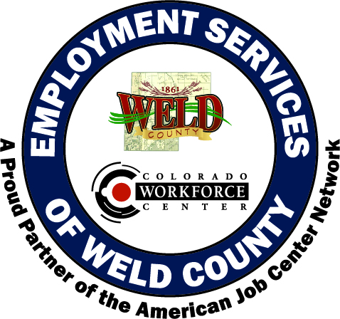
Sylvia Robinson, Weld WDB Chair and Joyce Saffel, Larimer WDB Chair, welcomed everyone to the second regional Larimer and Weld WDB meeting. Attendees identified important skills needed to be successful today and in ten years. Communication was the most cited skill needed today and adaptability was the most cited skill for 2030.

- Goals for Today (Sylvia Robinson and Joyce Saffel)
  - Review current regional projects
  - Brainstorm potential areas of collaboration
  - Identify regional WDB priorities
  - Begin implementation planning, including defining success

- Review Current Regional Projects (Jacob Castillo and Tami Grant)
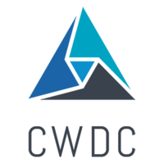
The region of Larimer and Weld is forecasted to be a metro area of about 1 million people by 2036. We are one region. We share talent, business, and industry. Since the first regional meeting regional partnerships and programs have expanded including the Work-based Learning Alliance, the Talent 2.0 regional workforce strategy, and sector partnerships.
- Brainstorm potential areas of collaboration (Jacob Castillo and Tami Grant)
  - Table Discussion: At your table please identify three potential areas of regional collaboration that best address WIOA WDB priorities
  - Please select one person to share identified priorities (Heather adds to presentation in real time)
WDB members discussed potential areas of collaboration. Please refer to the participant survey results for all feedback.
- Break

- Identify Regional WDB Priorities (Jacob Castillo and Tami Grant)
  - Review/discuss priorities identified
  - Table Discussion: Please consider all potential collaboration options.
  - Individual Mentimeter: Please prioritize potential collaboration options
Potential prioritized potential areas of collaboration identified are:
- Regional Workforce Symposium
- Future of Work joint meeting
- Talent 2.0 alignment
- Joint WDB meetings
- Regional programming
- Higher education alignment
- Work-based Learning Alliance
- Workforce Center accessibility
- Skillful workshops collaboration

- Implementation (Jacob Castillo and Tami Grant)
  - Individual Mentimeter: What resources are needed to achieve success
  - Individual Mentimeter: Would the Strategic Doing framework be useful in achieving these goals?
  - Individual Mentimeter: How will we know if we are successful?
WDB and meeting participants identified resources and success metrics. Please refer to the participant survey results for all feedback.

- Next Step (Jacob Castillo and Tami Grant)
  - Did we accomplish our goals for today?
    - Recap of discussion
Jacob and Tami will work with WDB leadership on next steps.

- Adjourn (Sylvia Robinson and Joyce Saffel)
The meeting adjourned at 10:03 am.

