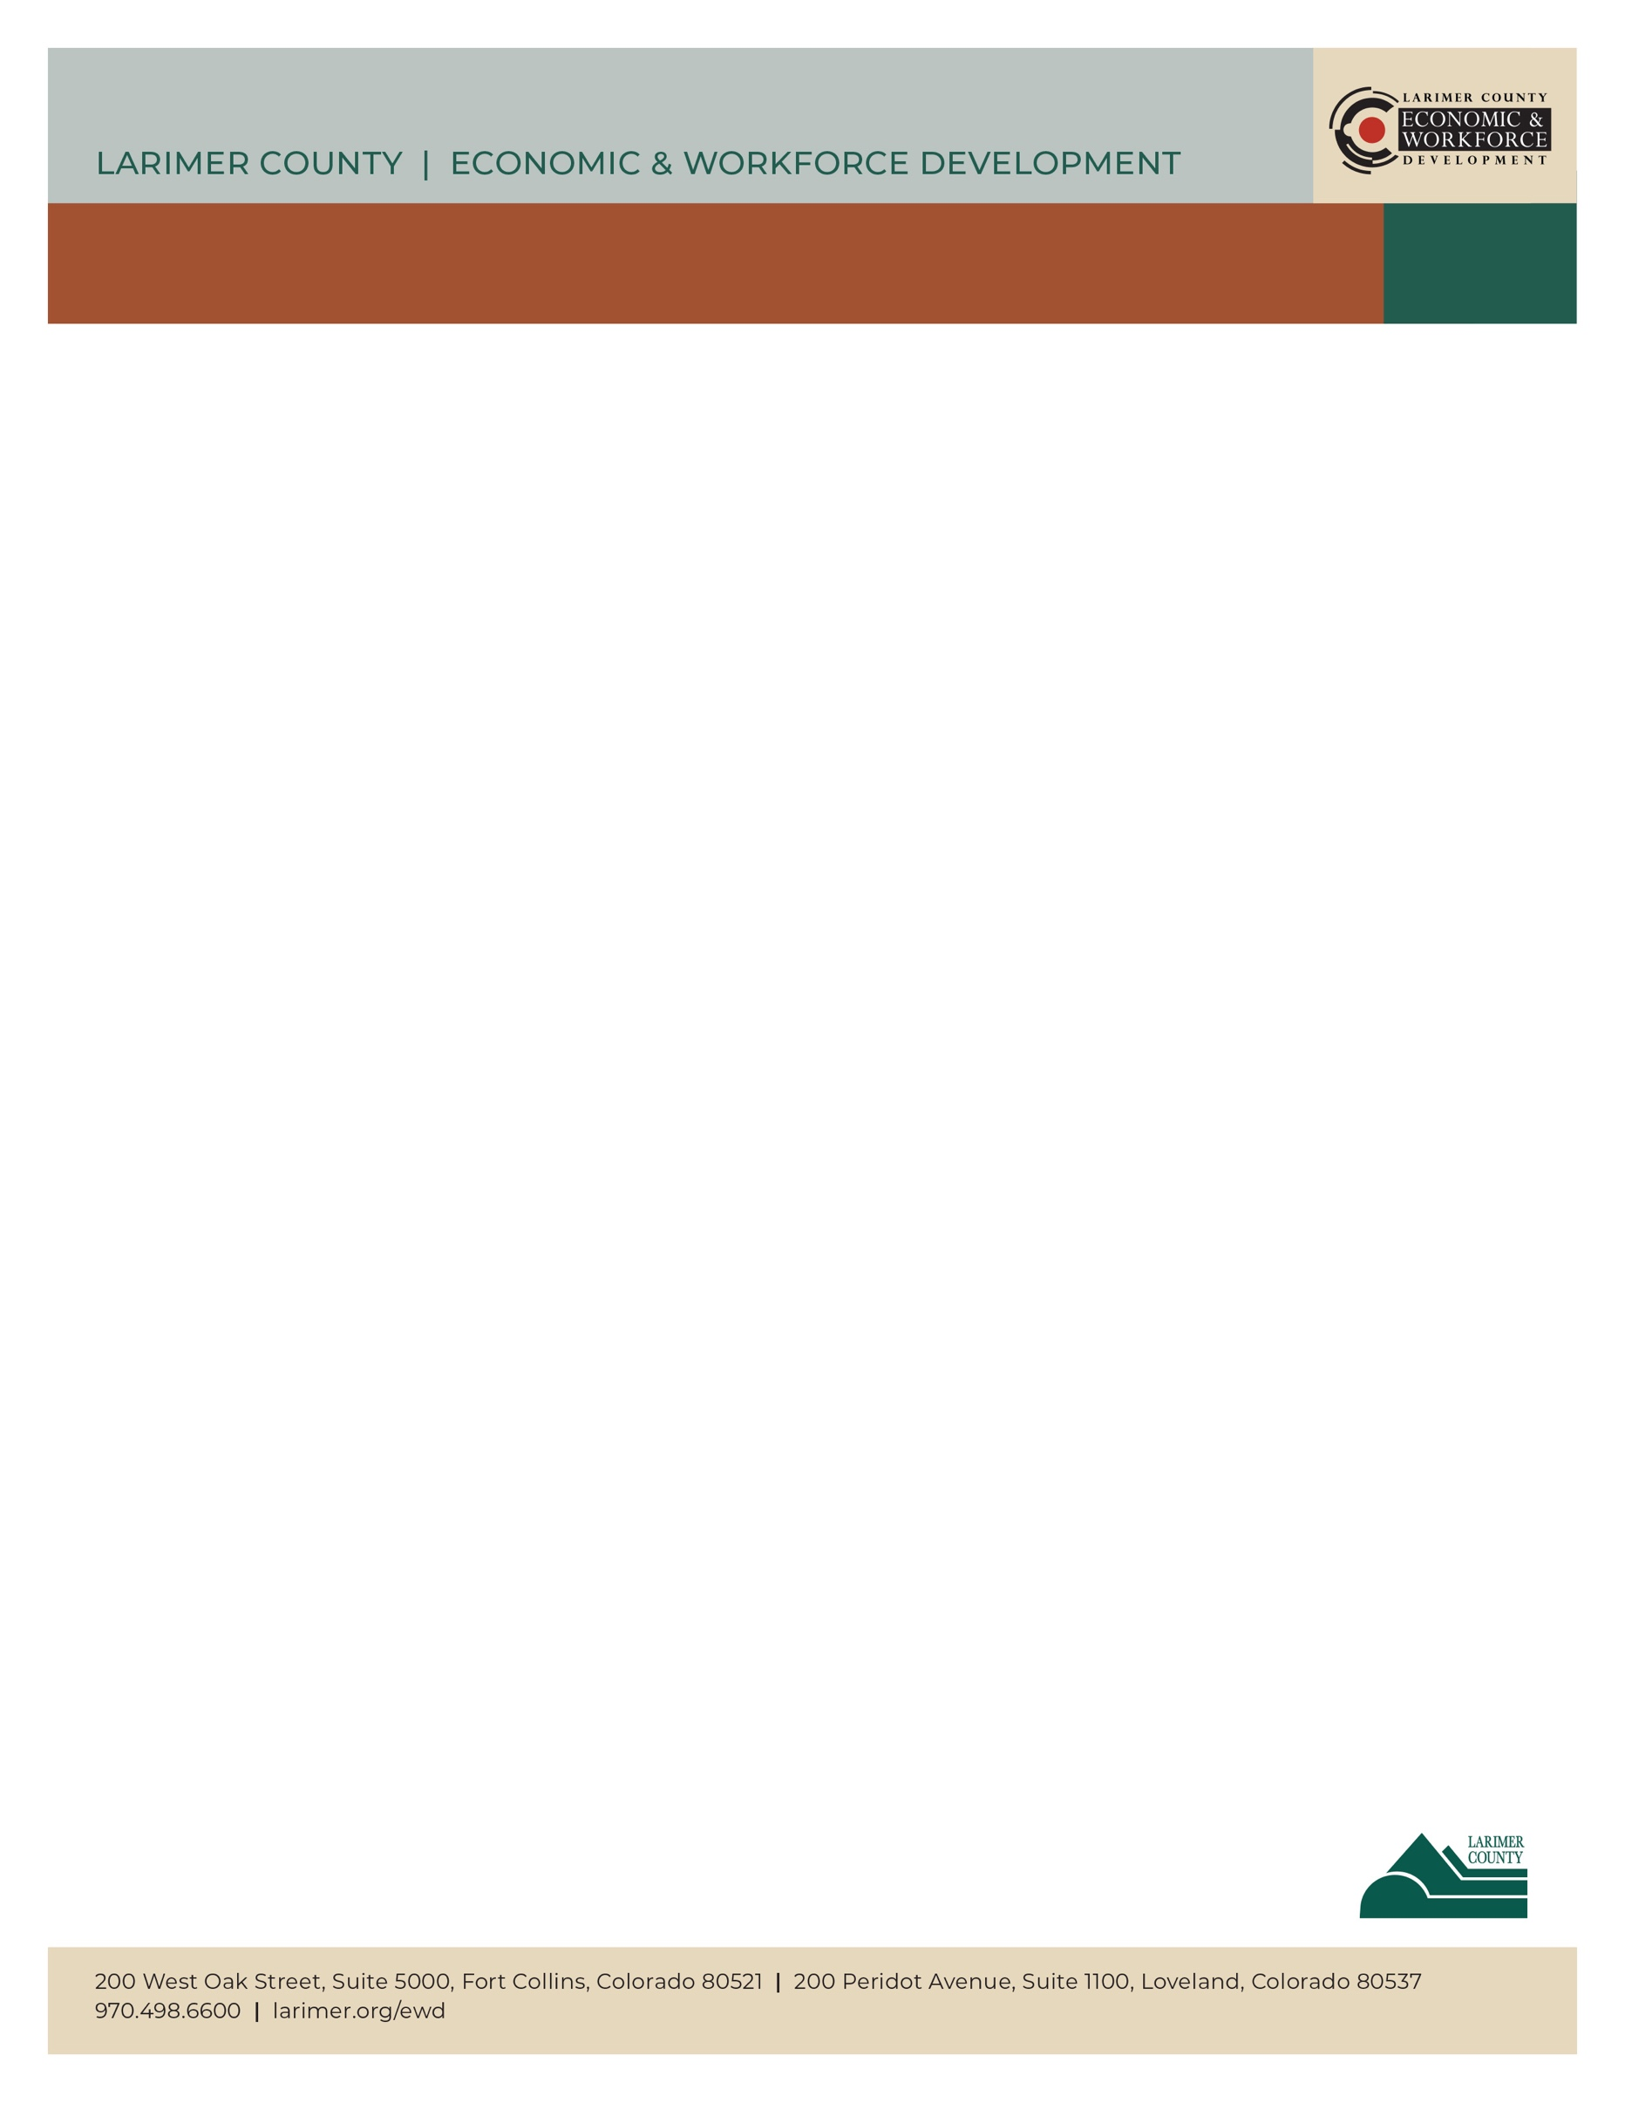

An interview is an opportunity to make a good first impression. Preparing for the interview will help you present your most relevant skills and tell your professional story.

**Know What to Expect- Research**

* Read and re-read the job description, highlighting all the essential knowledge, skills, and abilities
* Study the company website, including mission and value statements; learn about their products or services
* Talk to “insiders”; gather information from anyone who has worked at the company

**The S.T.A.R.-O Approach**

The STAR-O technique is a method for answering [behavioral interview](https://www.thebalancecareers.com/behavioral-job-interviews-2058575) questions (Give me an example of a time when…). Telling STAR-O stories provides concrete examples of your experience and skills needed for that position. It’s a good idea to prepare at least five to seven of these stories in advance.

1. **Situation/Set the Stage:** Briefly explain the context or goal.
2. **Task:** Describe, in detail, the task you needed to accomplish.
3. **Action:** Describe the action you took. What skills did you use? Keep the focus on yourself. Demonstrate what you *did* rather than what you would do.
4. **Result**: What happened? How did you solve the problem? What did you accomplish? What did you learn? What value did your actions bring?
5. **O:** Go full circle; summarize your skills and accomplishments. Tell the employer how you will use your skills to help make their business successful.

**Common Interview Questions**

**“Tell Me About Yourself.”**

Tell me about yourself is often the first question during an interview. This is your chance to engage the listener and make them want to know more about you. Organize your answer by focusing on your professional past, present, and future.

* Focus on your most relevant skills
* Limit your answer to two to three minutes
* Do not include personal, private, or family information
* Practice your answers out loud

**“Do You Have Any Questions for Me?”**

This is an opportunity for you to learn more about the company and demonstrate your interest in the company and your role. Never ask about wages or benefits until you receive a job offer.

**Example Questions:**

1. If I started this job tomorrow, what would be my first project?
2. What are the company’s growth plans for the next five years?
3. Keeping my skills up to date is important to me. Do you provide professional development opportunities?

*Seeker workshops:* [*https://www.larimer.org/ewd/workshops/job-seeker-workshops*](https://www.larimer.org/ewd/workshops/job-seeker-workshops)

*or email us at:* *lcewd-workforceconnections@co.larimer.co.us*

BE AN INTERVIEWNG S.T.A.R.

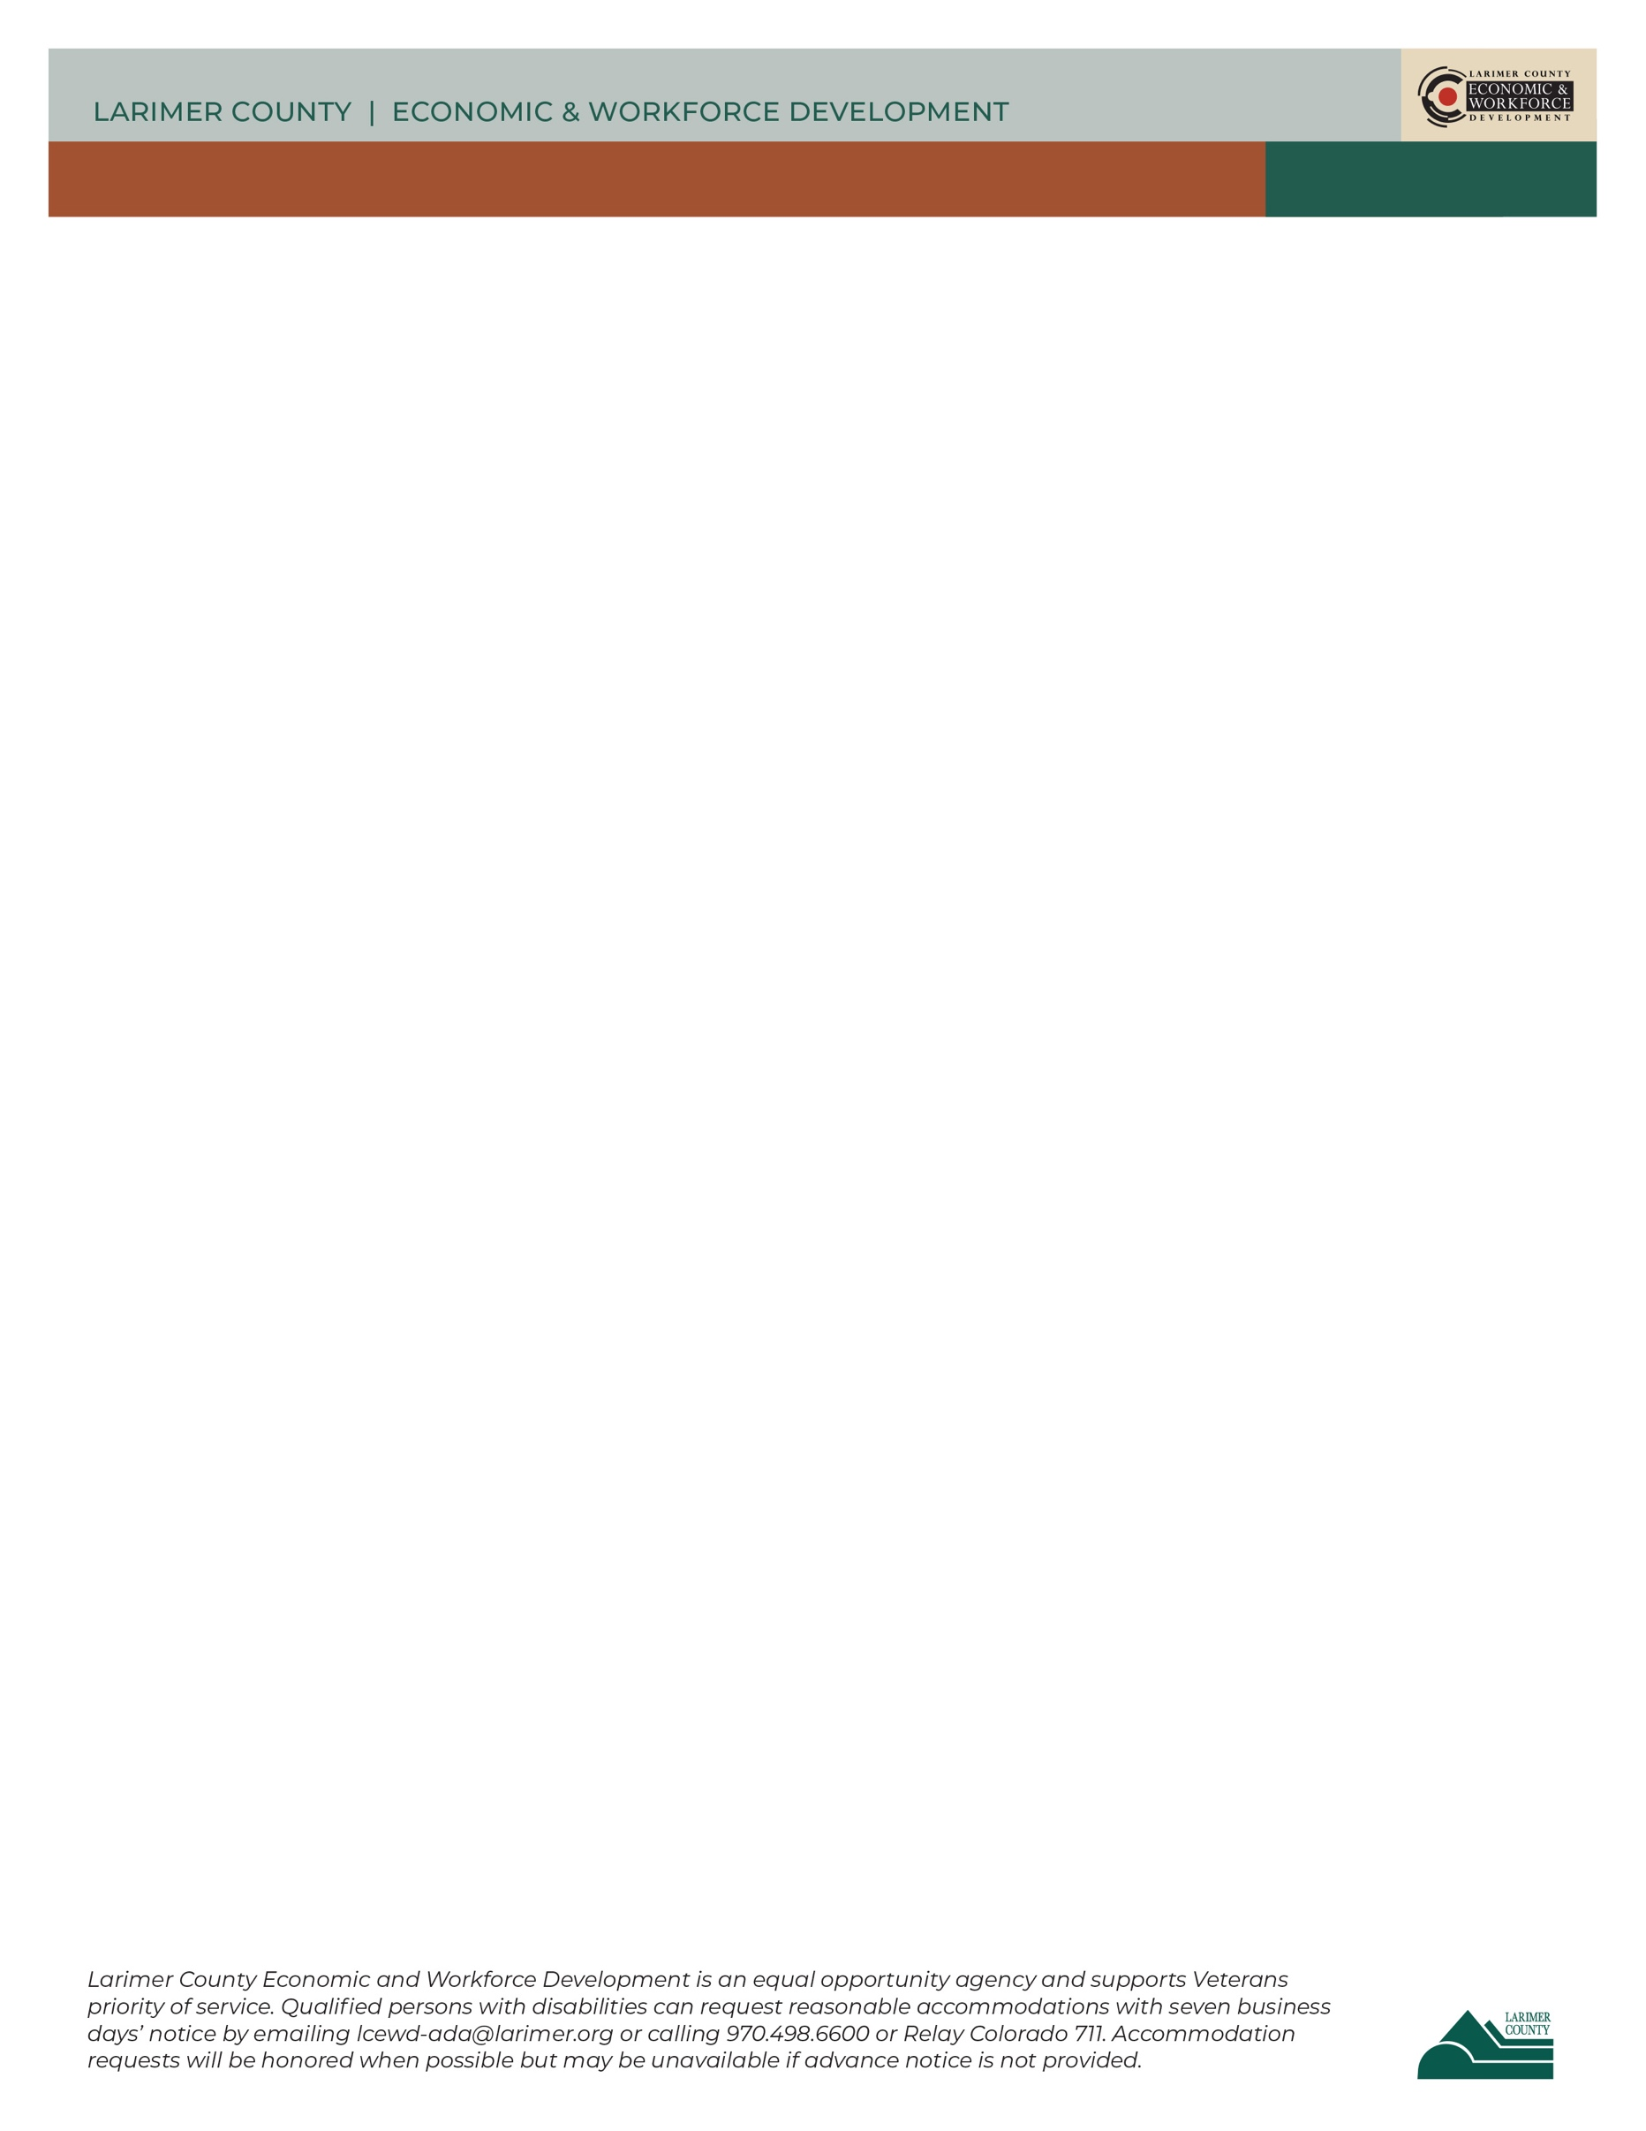

BE AN INTERVIEWING S.T.A.R.

**Challenging Questions**

Employers will sometimes ask questions that call for you to share mistakes, conflicts, and weaknesses. These can be the hardest questions to answer; preparation is key. Consider using the following criteria:

* Keep it small
* Describe situation in the past tense
* Choose something that does not provoke an emotional reaction
* Choose something that is already solved (or a solution that is in progress)
* Often, you can use a STAR-O story

**Explain Gaps in Work History**

When answering this question, be honest. Hiring managers understand that people lose their job or have life circumstances that take them out of the workforce. Describe what you were doing during this period; Were in school? Were you volunteering? How did you keep your skills up to date?

**Addressing Concerns**

Is there anything about you that could raise the employer’s concerns to the level where they would consider not hiring you? How can you address this concern in a way that will reduce the employer’s concern so they can concentrate on your qualifications? Prepare your answers prior to the interview; demonstrate self-awareness, speak directly without embarrassment, and have a positive attitude. Answer with confidence by focusing on your relevant skills.

**Preparing for the Big Day**

* Do research prior to the interview to decide what to wear; business casual is usually a good choice
* Wear clean, professional clothing, minimal jewelry and make-up, and cover tattoos or piercings
* Bring a note pad and pen, several copies of your resume, work samples, or other material related

to the job

* Bullet point your STAR- O. stories and questions for in interviewer on your note pad
* Take brief notes during the interview to help keep yourself on track

**Non-Verbal Communication**

* Make eye contact with the interviewer for a few seconds at a time
* Smile and nod (at appropriate times) when the interviewer is talking
* Relax and lean forward a little towards the interviewer to show your interest and engagement
* Listen to the complete question before responding

**Follow Up- Thank You Letters**

A thank you note, or email is another opportunity to sell your qualifications and relevant skills. Briefly include any pertinent information you failed to mention earlier. Be sure to reemphasize your qualifications and skills for the job. Send within 1-2 business days after the interview.