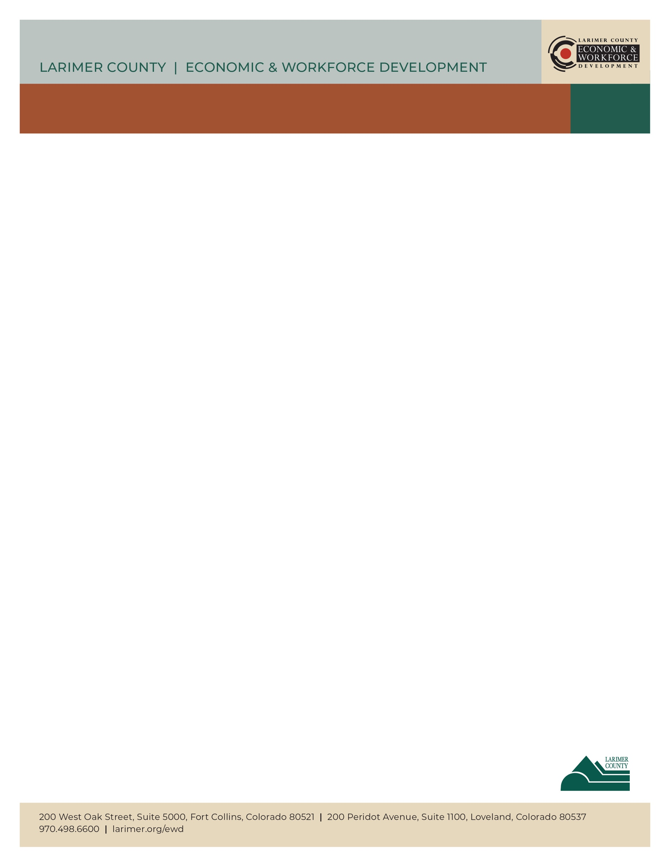

INFORMATIONAL INTERVIEWS/CONVERSATIONS

**Time for a Career Change?**

**Informational Interviews/Conversations**

**What are Informational Interviews/Conversations? ­**

An opportunity to discover information about potential roles or jobs and industries.

* Gain valuable information about a career field or job within the field or a specific employer.
* Learn from people who work directly in your area of interest.
* Explore careers and clarify your career goals.
* Broaden your network of contacts for future reference.
* Build confidence for job interviews.
* Access the most up-to-date career information.
* Create a strategy for entering your field of interest.
* Better understand a specific work environment.

**How to Request an Informational Conversation**

**Introduce yourself:**

Hello, my name is _________________. I am in career transition and exploring new career paths. I would like to learn more about _______________________ (name of role/job). It would be helpful to me if we could spend a short amount of time together so I can learn more about the highlights and challenges in this line of work, the demand for jobs in our region, and your suggestions for how to become well qualified in this field.

**Preparation**

* Learn as much as you can about the person with whom you will be interviewing in advance so you can quickly build rapport and use the short amount of time productively (LinkedIn as a resource).
* Research your area of interest before the interview to gain a basic understanding of the occupation. Develop questions for the informational interview that will provide you specific information.
* Consider sending (e-mailing) a copy of your questions to the interviewee before you meet to give them time to prepare.
* Dress professionally.

**Follow Up**

* Send a professional thank you note or email.
* Review your notes and evaluate what you learned. Analyze the information you gathered; what adjustments do you need to make to your job search, career goals, and resume?
* Stay connected with your contact to let them know the results of their referrals and how

your conversation was helpful.

* Ask if there’s anything you can do for them in return for their assistance.

*Resume and Job Seeker workshops:* [*https://www.larimer.org/ewd/workshops/job-seeker-workshops*](https://www.larimer.org/ewd/workshops/job-seeker-workshops)

*or email us at:* *lcewd-workforceconnections@co.larimer.co.us*

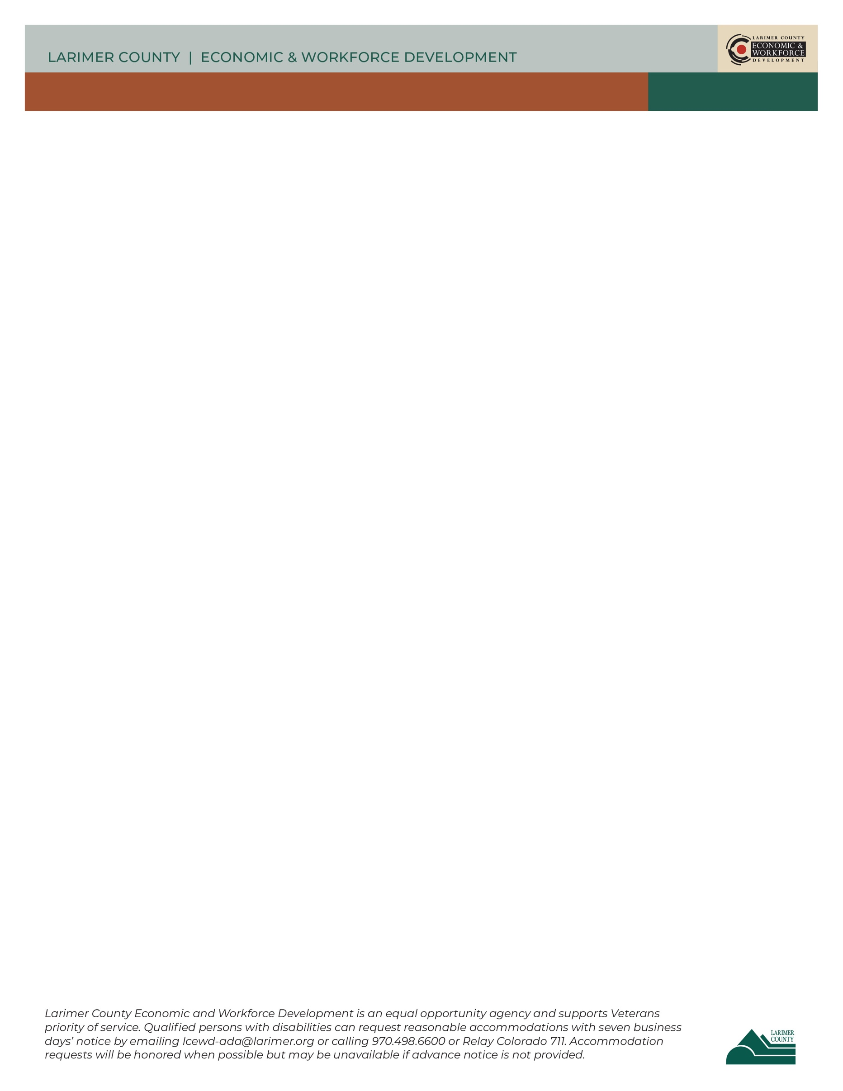

**Sample Questions:**

Choose several questions from the following list that focus on your objectives for the interview. The list isn’t comprehensive, so brainstorm some additional questions.

1. What are your roles and responsibilities within the organization?
2. What are some of the different types of professional roles within your organization?
3. What education or training is most valued? Is a degree necessary?
4. What types of skills, aptitudes, or personality traits are needed for success in this type of work?
5. What are the areas of knowledge most relevant to advancement in this field?
6. Are people needed in this field?
7. What trends or issues do you see shaping the direction of this field in five to ten years?
8. How did you get into this field or job?
9. What do you like best about the job?
10. What is the starting salary range? How does the range change at different levels of advancement?
11. Where can a person interested in this occupation find further information?
12. What is the best advice you can give a person interested in this occupation?
13. What are some of the challenges of this occupation?
14. **ALWAYS ASK**: Who else do you know who would be helpful for me to speak with? When I contact them, may I use your name?