

Cover letters are an important part of your application; just like your resume they need to be targeted and customized.

**3 Goals of a Cover Letter**

* Tell your professional story and describe how you will add value to the company
* Address career transitions or explain gaps in your work history
* Add details that focus on your skills and accomplishments, rather than a summary of your resume

**Cover Letter Outline**

* Use the same header as your resume
* Include a date, a job posting number if relevant, and the contact information of the company
* Address to a specific person. Do not use “To whom it may concern”. If you don’t have a person’s name use, “Dear Hiring Manager”
* Keep the letter to one page unless otherwise specified

1. **Make a connection**

* Start with something that immediately connects you with the company and make it memorable
* If someone in the company has agreed to be a reference, mention them here
* State where you saw the job posting
* Demonstrate what you know about the company and the industry. Incorporate the company’s goals, mission, or vision and how you can help them accomplish these objectives

1. **How will you add value?**

* Quantify and qualify your experience; include proof of your success, highlight your skills, expertise, and abilities
* Use keywords from the job description
* Highlight past jobs and accomplishments that relate to this job
* Provide a balance of hard and soft skills
* If transitioning careers explain the transition; provide examples of how your experience

translates into the new role

1. **Ask for the interview**

* Tell the employer you would like to have a direct conversation
* You will contact them in so many days to be sure they received all your materials
* Thank them for their time
* Make sure you follow through and do what you stated in your cover letter

*Resume and Job Seeker workshops:* [*https://www.larimer.org/ewd/workshops/job-seeker-workshops*](https://www.larimer.org/ewd/workshops/job-seeker-workshops)

*or email us at:* *lcewd-workforceconnections@co.larimer.co.us*

HOW TO WRITE A COVER LETTER

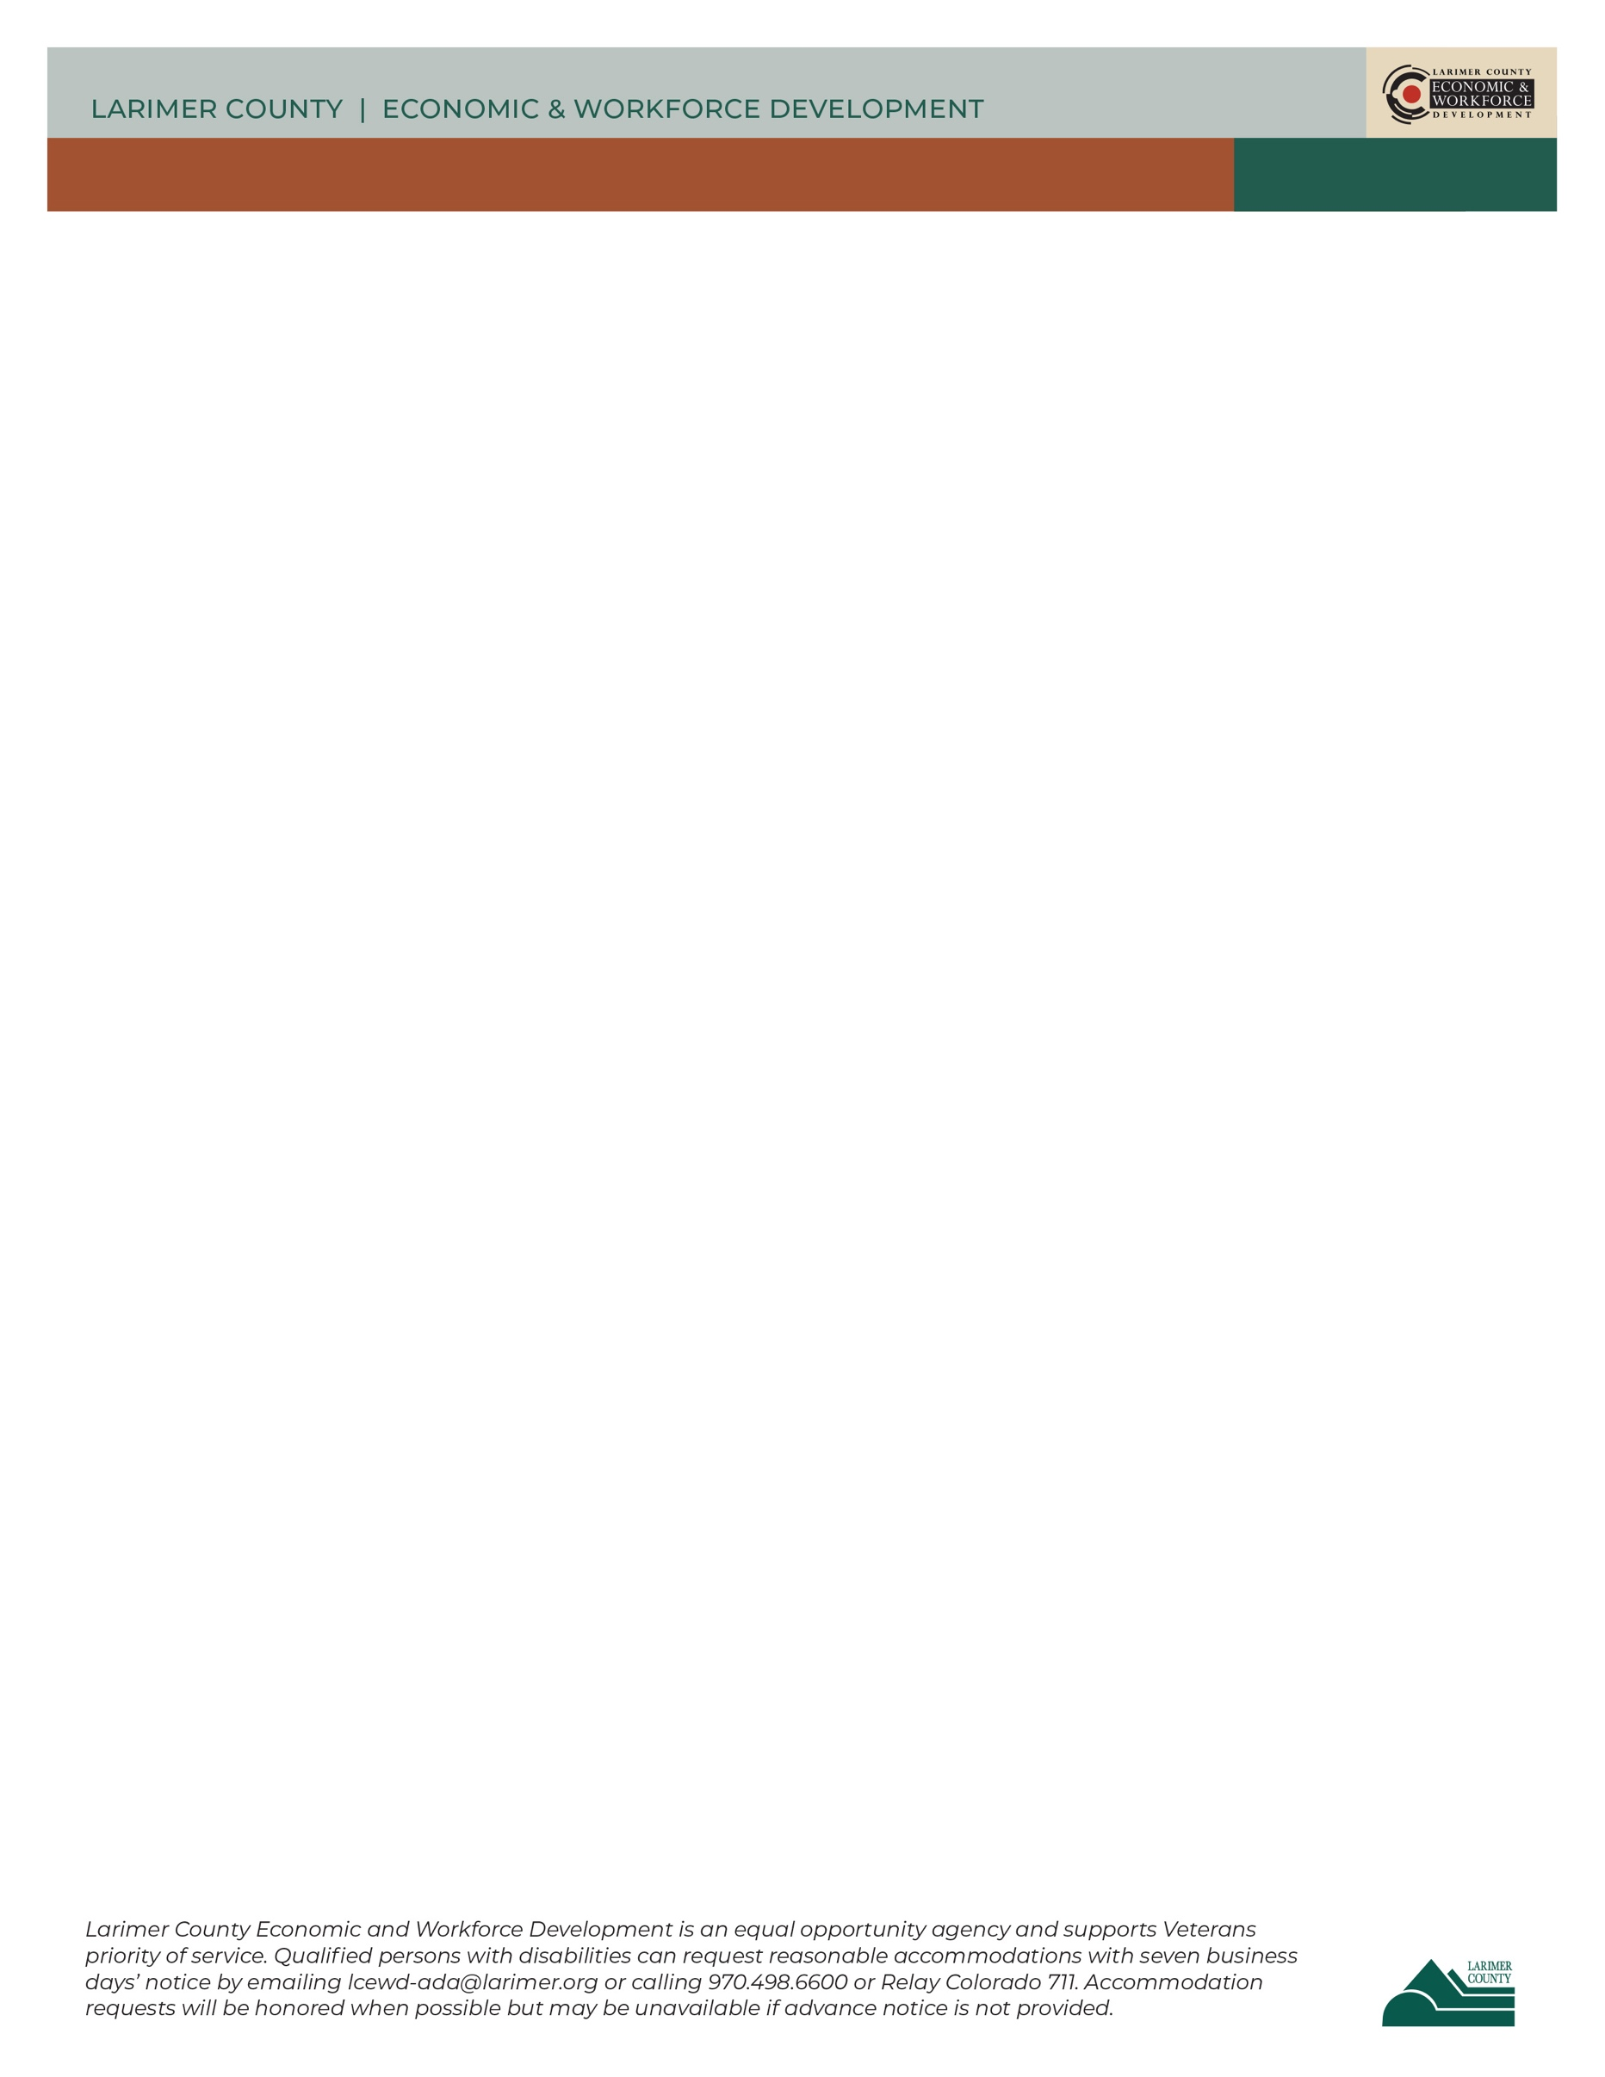

**Personal Header**

(Use resume header)

Date

Contact Name

Name of Employer

Address of Employer

City, State, Zip

Re: [this is optional; identify position name and reference #]

Dear First Name Last Name,

I am writing to apply for the position of Paralegal for ABC Law Firm, as advertised on Indeed. In my 5-year career as a paralegal, I honed my legal research and writing skills. The attorneys I have worked with have complimented me on my command of case law and litigation support. ABC Law Firm’s 20 years in practice proves that the firm has strong values and excellent attorneys, which is why I want to be a part of your team.

I currently serve as a paralegal, where I work closely with the partners in several high-priority cases. To meet deadlines with 100% accuracy, I implemented a calendar system to ensure the timely filing of court papers. This system not only prevented missed deadlines but also allowed for better organization of internal and client communication.

I welcome the opportunity to discuss how I can contribute to your legal team. I will follow up with you in a few days to discuss possible next steps. Thank you in advance for your consideration.

Sincerely,

<Signature>

HOW TO WRITE A COVER LETTER